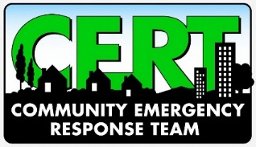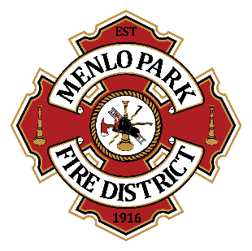
Menlo Park Fire Protection District
Appendix E:
CERT/Emergency Preparedness Class Trainer

Menlo Park Fire Protection District (MPFPD) trainers are volunteers or paid contractors who have the professional background or have gone through additional training to become proficient in the knowledge and skills needed to teach CERT, LISTOS, First Aid/CPR/AED, Stop the Bleed, Red Cross Ready, or other courses as required. Some examples of the required background or training include professional current or retired firefighter, or completion of CERT/LISTOS train-the-trainer course.

Individuals who would like to be considered for a training role must first observe a minimum of one MPFPD course, apprentice with an experienced instructor, then be observed by a current instructor to be eligible.

Trainer skills include but are not limited to: knowledgeable in subject matter, engaging teaching style, strong time management and organizational skills, strong interpersonal skills, positive and energetic personality.

To teach CERT or other courses sponsored by MPFPD, trainers must work in coordination with MPFPD. MPFPD is the sponsoring agency for MPFPD CERT and therefore are the only agency that can oversee and teach CERT courses in the MPFPD jurisdiction.

Approved trainers are continually evaluated and may be asked to step down from the trainer role at any time if they are determined not to be the right fit.

By signing below, I acknowledge that:

- I am acting under the authority of the Menlo Park Fire Protection District, and I may be relieved of this role at any time, for any reason, by MPFPD.
- I will complete a LiveScan background check at MPFPD’s expense.
- I will ensure that each training I deliver is within the scope of the corresponding course or curriculum and is approved by MPFPD.
- I will work closely with the MPFPD to support the types of trainings or specific classes that have been scheduled for the calendar year, as well as make suggestions based on past experiences and/or new areas of expertise.
- I will follow all steps requested to shadow, observe, and be observed as part of the training process.
- I will successfully complete any required train-the-trainer or advanced training courses.
- As a trainer, I recognize that safety is the top priority in any activity. I will model safe behavior for all class participants, and safety will be emphasized in all aspects of my instruction.
- I will maintain my skills and any necessary certifications in the subject matter that I intend to teach.
- I agree to teach a minimum of two (2) classes each year.
- I understand that as a trainer, the students/participants will evaluate me. I will accept constructive feedback and will incorporate recommended improvements as requested.
- If for any reason I cannot continue as a trainer, I will notify the MPFPD and will forward all records, contact information, calendars, lesson plans, presentations, etc. related to the courses and program.

I accept the role of trainer for the Menlo Park Fire Protection District and agree to follow and abide by all conditions and rules set forth in this agreement.

________________________________________
Print Name

________________________________________
Signature

________________________________________
Cell Phone

________________________________________
Email Address

