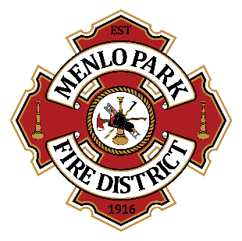
Menlo Park Fire Protection District Community Group Engagement
Guidelines
DRAFT- June 2023

Background
The Menlo Park Fire Protection District leads and supports emergency preparedness efforts throughout the community. A primary goal is to increase individual and community awareness and preparedness for all potential emergencies and disasters. These efforts align with MPFPD’s mission to protect and preserve life and property from the impact of fire, disaster, injury, and illness.

Community and business Groups
The Menlo Park Fire Protection District jurisdiction includes several community and business groups in Menlo Park, East Palo Alto, Atherton, and unincorporated areas. These groups focus either entirely or partially on educating and preparing their communities for emergencies and disasters. MPFPD supports the efforts of these community groups in helping to raise awareness and work towards more prepared neighborhoods and communities.

Roles and Representation
Community groups in the MPFPD jurisdiction operate independently of the MPFPD. The MPFPD encourages the work of our community and business groups and strives for continued collaboration and partnership.
We encourage community and business groups to continue with their efforts to raise awareness and support emergency preparedness and educational opportunities for the members of their neighborhood groups and the surrounding community. Groups may choose to host their own events, trainings, and gatherings, and they may also encourage their members to attend MPFPD trainings and classes.
MPFPD is the sponsoring agency for CERT and oversees this program. Community members may participate in CERT trainings for further education, or to become a CERT member. Some may also choose to participate in CERT train-the-trainer sessions.
CERT members may only be assigned to participate in MPFPD activities or activated to respond to an emergency by MPFPD personnel. Members of other community or business groups may follow their procedures to take care of their teams and neighbors but may not activate as a CERT member unless initiated by MPFPD.
Many members of our community and business groups represent more than one group. For example, an individual may be a member of ADAPT, and a member of MPFPD CERT. It is important to distinguish these roles and keep in mind the representation of each group.
When individuals are participating in activities for a community group or at a public community event, they should be clear with which group they are representing. This includes wearing the appropriate apparel with logos, handing out relevant materials, etc.
For those who participate in CERT train-the trainer, they may be considered for opportunities to teach MPFPD CERT classes. They should not teach CERT classes in the community independent of MPFPD. CERT is a standardized national program that is under the umbrella of FEMA (Federal Emergency Management Agency) and must be managed through the local sponsoring agency (MPFPD).

Program Support
MPFPD can provide some program support to our community groups. Examples include providing MPFPD employees to teach classes and trainings and paying for printing educational materials. MPFPD does not directly contribute monetary donations to community groups. Additional requests for program support will be evaluated on a case-by-case basis. Additional support for community and business groups shall follow Fire Board policy.

MPFPD will host regular meetings with our community groups for continued collaboration and support among the groups, and MPFPD. Meetings will be held quarterly, or as needed.

