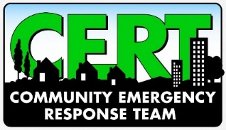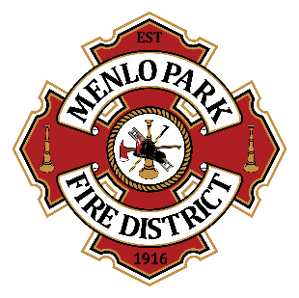
Menlo Park Fire Protection District
Appendix D: CERT Trailer Team
DRAFT- June 2023
The Menlo Park Fire Protection District Community Emergency Response Trailer Team is made up of active MPFPD CERT volunteers. The goal of the team is to inspect and help maintain MPFPD trailer resources and ensure equipment is in a deployable, ready state. The team will have responsibility for, and access to, neighborhood and emergency trailers and caches.

By signing below, I acknowledge that:

- I am acting under the authority of the Menlo Park Fire Protection District and I may be relieved of this role at any time, for any reason, by MPFPD.
- I will access the trailers and/or trailer storage area with at least one other trailer team member, never alone.
- I will not bring pets, children, or any other individuals not previously authorized by MPFPD to the trailer storage area.
- I will maintain the security of the trailers and trailer storage area by ensuring all locks are properly secured and by safeguarding any combinations or passcodes provided to me by MPFPD. I will immediately report any breach of security to the Community Volunteer Coordinator.
- I will not drink alcohol, smoke or vape while at the CERT trailer area.
- For the purposes of safety and identification, I will wear a CERT vest, closed-toed shoes, long pants, and work gloves at all times while at the trailer area.
- Trailer teams will visit and inspect all trailers at least quarterly.
- I will notify the Community Volunteer Coordinator at least two days prior to accessing the trailers to perform the quarterly maintenance (inventory and documentation) activities.
- Any maintenance needs that can’t be addressed at the time of the visit and any supplies that need to be replaced should be noted and reported to the Community Volunteer Coordinator.
- I will operate all equipment safely and within the scope of my training.
- I understand that towing any MPFPD trailer must be done with a MPFPD vehicle by a qualified individual who has completed the MPFPD trailer towing training.
- All resources and equipment must remain at the storage site unless advance permission is granted by MPFPD to remove an item from the area.
- I will not store any personal property or equipment in the MPFPD trailers or trailer storage area unless advance permission is granted by the MPFPD.
- Any items in need of disposal will be removed from the trailer storage area and disposed of properly. Questions about proper disposal should be directed to the Community Volunteer Coordinator.
- If for any reason I cannot continue as a Trailer Team Member, I will notify the MPFPD immediately and will forward all records, contact information, etc.

I accept the role of Trailer Team Member for the Menlo Park Fire Protection District and agree to follow and abide by all conditions and rules set forth in this agreement.

________________________________________
Print Name

________________________________________
Signature

________________________________________
Cell Phone

________________________________________
Email Address

