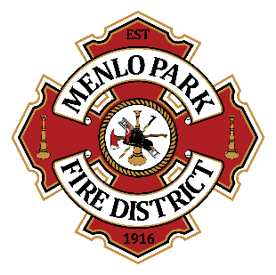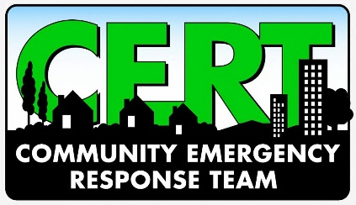
Menlo Park Fire Protection District CERT
Appendix A: Participation Levels

Levels
All community members are eligible to take CERT Basic Training and achieve Level 3: Awareness status or take the additional steps needed to achieve Level 2: Response status. To reach Level 1: Advanced status, members are appointed at the discretion of the Community Volunteer Coordinator and status may be revoked at any time.
- Level 3: Awareness
  - Completed Basic CERT Training
  - Upon completion, a certificate will be issued.
  - Recommended to participate in a training class, refresher course, drill, or exercise at least every two years
  - No Disaster Service Worker (DSW) status
- Level 2: Response
  - Completed Basic CERT Training
  - Upon completion, a certificate and CERT ID card will be issued.
  - Required to participate in at least one training class, refresher course, drill, or exercise per year
  - Required to take IS-100 Intro to ICS Course; additional courses are optional
  - Complete DSW registration
  - Can staff CERT booths at community events and can be activated as a CERT responder
- Level 1: Advanced
  - Completed Basic CERT Training
  - Upon completion, a certificate and CERT ID card will be issued.
  - Required to participate in at least two training classes, refresher courses, drills, or exercises per year
  - Required to take IS-100 Intro to ICS Course, Basic First Aid/CPR, IS-200 ICS for Single Resources, IS-700 NIMS, Red Cross Shelter Ops/Fundamentals, Stop the Bleed; additional courses are optional
  - Complete DSW registration
  - Can staff CERT booths at community events and can be activated as a CERT responder

Training Level Matrix

Level 3: Awareness | Level 2: Response | Level 1: Advanced | Component
X | X | X | CERT Basic Training
X | X | X | IS-315 CERT ICS
 | X | X | IS-100 Intro to ICS
 | X | X | Attend two trainings per year  (e.g., skills day, continuing ed classes, practice drills)
 | O | X | Basic First Aid (kept current)
 | O | X | CPR (kept current)
 | O | X | IS-200 ICS for Single Resources
 | O | X | IS-700 NIMS
 | O | X | Red Cross Shelter Ops/Fundamentals
 | O | X | Stop the Bleed
 | O | O | Amateur (HAM) Radio License (kept current)
 | O | O | National CERT Association Membership (kept current)
 | O | O | IS-2200 Basic Emergency Operations Center (EOC) Functions
 | O | O | CERT Animal Response
 | O | O | CERT Advanced Training (Annexes)
 | O | O | Disaster Psychology (continuing education)
 | O | O | CERT Helping the Helper
 | O | O | CERT Firefighter Rehabilitation
 | O | O | CERT Traffic & Crowd Management
 | O | O | CERT Train-the-Trainer (TTT or T3)
 | O | O | G-108 Community Mass Care & Emergency Assistance
 | O | O | IS-368 Including People with Disabilities in Disaster Operation
 | O | O | IS-240 Leadership & Influence
 | O | O | NOAA Skywarn
 | O | O | Red Cross Care Assistance Fundamentals
 | O | O | Red Cross Psychological First Aid
 | O | O | Red Cross Shelter Manager
 | O | O | Shelter Exercise
 | O | O | Urban Search & Rescue

X= Required
O= Optional

