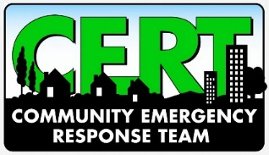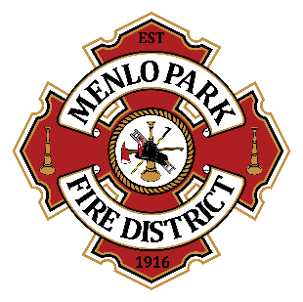
Menlo Park Fire Protection District
Appendix C: CERT Neighborhood Leader
CERT Neighborhood Leaders consist of active volunteers of the Menlo Park Fire Protection District Community Emergency Response Team program. The goal of Neighborhood Leaders is to engage volunteers in their neighborhood at least semi-annually to encourage building relationships and working towards a more prepared community. These leaders are expected to take individual initiative to facilitate and organize neighborhood-level activities that support the mission of CERT. Neighborhood Leaders work closely with the Community Volunteer Coordinator to facilitate information flow and to address any items of concern to the MPFPD.

By signing below, I acknowledge that:

- I am acting under the authority of the Menlo Park Fire Protection District, and I may be relieved of this role at any time, for any reason, by MPFPD.
- I will complete a LiveScan background check at MPFPD’s expense.
- I will ensure CERT volunteers are able to interact, train, and socialize together to build relationships and ensure a resilient community. I will coordinate semi-annual get-togethers at a neighborhood venue that works well for my group members.
- I will keep the Community Volunteer Coordinator informed about activities and meetings with my neighborhood CERT members and will ensure that copies of sign-in sheets are forwarded to have hours tracked.
- Safety will be a top priority for all activities I organize.
- CERT volunteers’ contact information (email, phone, home address, etc.) will be used strictly for CERT-related communications. I understand that I may be entrusted with personal information and agree to be responsible and discrete with any personal or sensitive information pertaining to CERT volunteers, MPFPD personnel, or MPFPD operations.
- I will keep the Community Volunteer Coordinator informed of any challenges related to my neighborhood CERT volunteers including but not limited to stepping outside the scope of their role, uncooperative or inappropriate interactions, communication challenges, etc.
- I will maintain an active status in the CERT program as outlined in the MPFPD CERT Standard Operating Procedures.
- I understand that as a Neighborhood Leader, the neighborhood CERT members may evaluate me. I will accept constructive feedback and will incorporate recommended improvements as requested.
- If for any reason I cannot continue as a Neighborhood Leader, I will notify the MPFPD immediately and will forward all records, contact information, calendars, lesson plans, presentations, etc. related to the courses and program.

I accept the role of Neighborhood Leader for the Menlo Park Fire Protection District and agree to follow and abide by all conditions and rules set forth in this agreement.

________________________________________
Print Name

________________________________________
Signature

________________________________________
Cell Phone

________________________________________
Email Address

