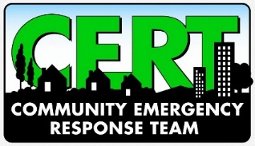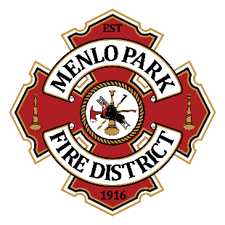
Menlo Park Fire Protection District
Appendix B: CERT Communications Team

The Communications Team is made up of active volunteers of the Menlo Park Fire Protection District (MPFPD) Community Emergency Response Team (CERT) volunteers. They are dedicated to the use of Amateur Radio (HAM), Family Radio Service (FRS), Citizens Band (CB), General Mobile Radio Service (GMRS), and/or Multi-Use Radio Service (MURS) radios for the communication of CERT teams within a neighborhood, and/or between division posts, cities, and the Emergency Operations Center (EOC). CERT Communications Team volunteers should be well-versed in ICS and are encouraged to take advantage of opportunities to keep their skills current. CERT Communications Team members who operate HAM, MURS, CB, or GMRS radios must have the appropriate Federal Communications Commission (FCC) operator’s license.

By signing below, I acknowledge that:

- I am acting under the authority of the Menlo Park Fire Protection District and I may be relieved of this role at any time, for any reason, by MPFPD.
- I will participate in periodic trainings and Nets, and will facilitate radio communications during events such as Skills Day at least twice per year.
- I will primarily use my own personal radio equipment, purchased and maintained at my own expense.
- If asked to use MPFPD CERT radios and equipment, I will do so with care and in accordance with any FCC license requirements.
- All MPFPD CERT radios and equipment will be checked out and checked back in. Should any maintenance or repairs be needed, I will notify the Community Volunteer Coordinator.
- I take full responsibility for maintaining my eligibility to operate radio equipment and will keep my radio license(s) current and in good standing as required by the FCC at my own expense.
- If my FCC radio license(s) should expire or lapse, I will notify the Community Volunteer Coordinator.
- I will not store any personal property or equipment in the MPFPD CERT trailers or trailer storage areas unless advance permission is granted by the MPFPD.
- I will maintain an active status in the MPFPD CERT program as outlined in the MPFPD CERT program SOP.
- If for any reason I cannot continue as a Communications Team Member, I will notify the MPFPD and will forward all records, contact information, etc.

I accept the role of Communications Team Member for the Menlo Park Fire Protection District and agree to follow and abide by all conditions and rules set forth in this agreement.

________________________________________
Print Name

________________________________________
Signature

________________________________________
Cell Phone

________________________________________
Email Address

